Semicircular-Region Generator

Definition
# Source: AI Source: Provided by: [Data Path: Persons Table -> ID Column: 1, Name_En Column: Motasem Essam] -> From: [ChatGPT] on [7/25/2026]
A Semicircular-Region Generator is a plane-region generator that uses a filled semicircular region (half-disk) to produce three-dimensional solids through rotation, translation, or other spatial movements.
The most important application is rotating a semicircular region around its diameter to generate a Solid Sphere.
Other movements can generate half-cylinders, semicircular prisms, and other swept solids.
Important distinction:
- A semicircular region (half-disk) is the filled area enclosed by a semicircular arc and its diameter.
- A semicircular arc is only the curved boundary and does not include the filled area.
- Rotating a semicircular region around its diameter generates a solid sphere, whereas rotating only its semicircular arc generates a spherical surface.

Geometric Representation
# Source: AI Source: Provided by: [Data Path: Persons Table -> ID Column: 1, Name_En Column: Motasem Essam] -> From: [ChatGPT] on [7/25/2026]
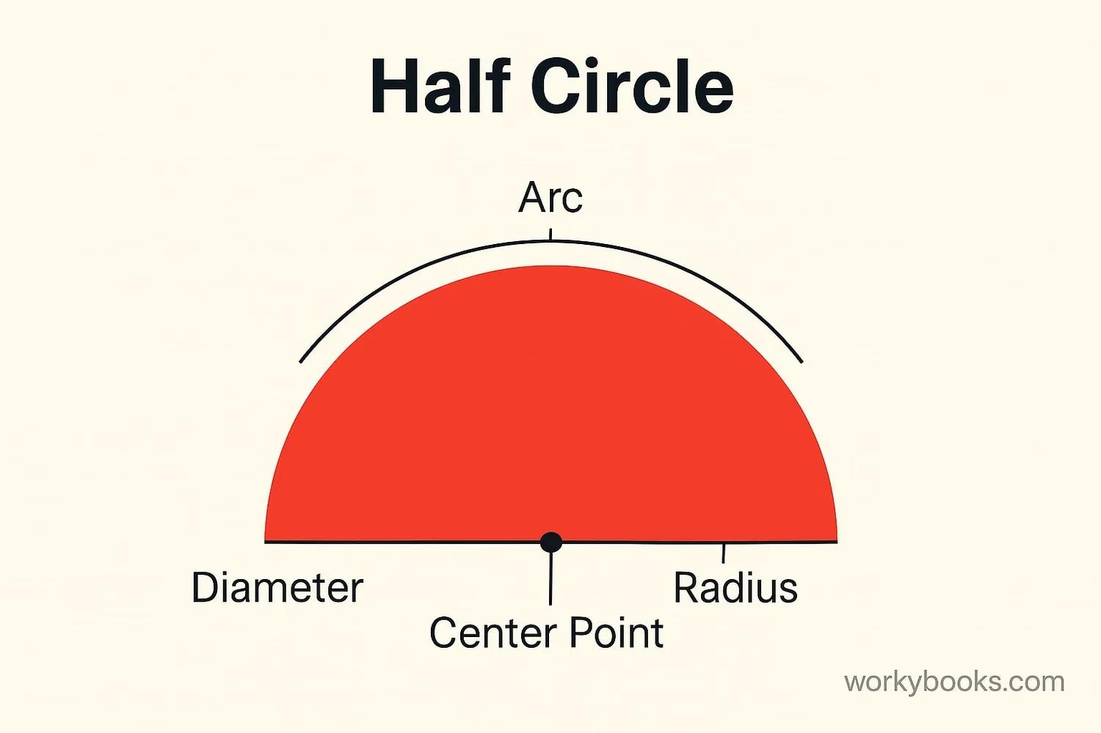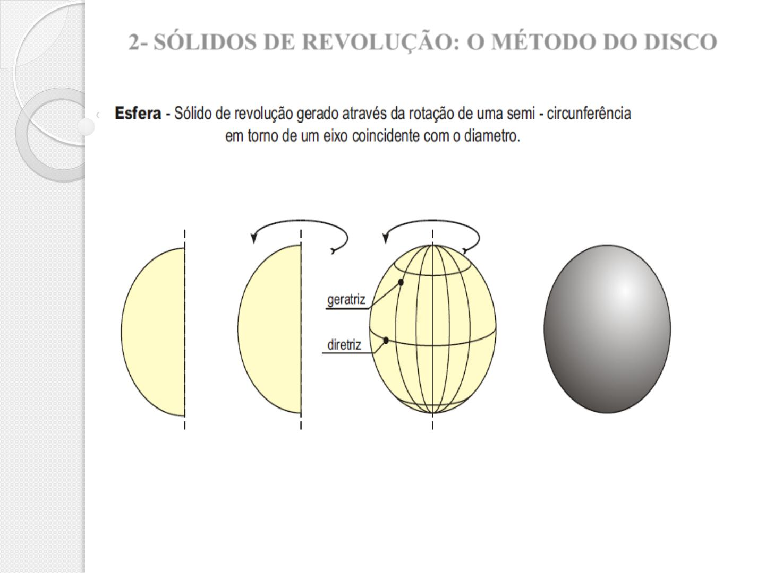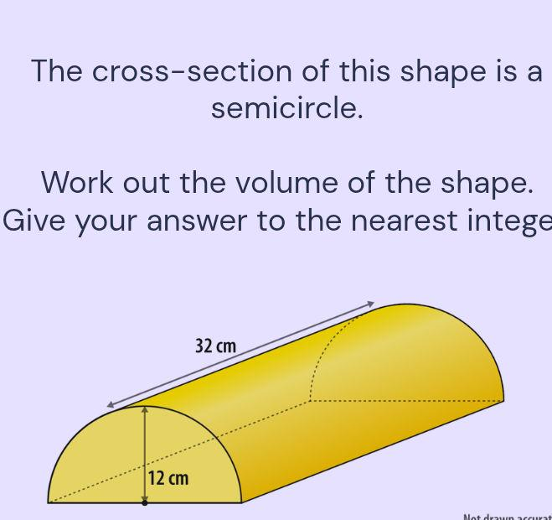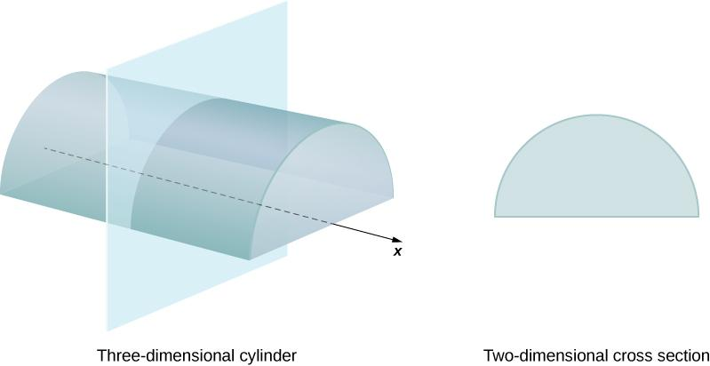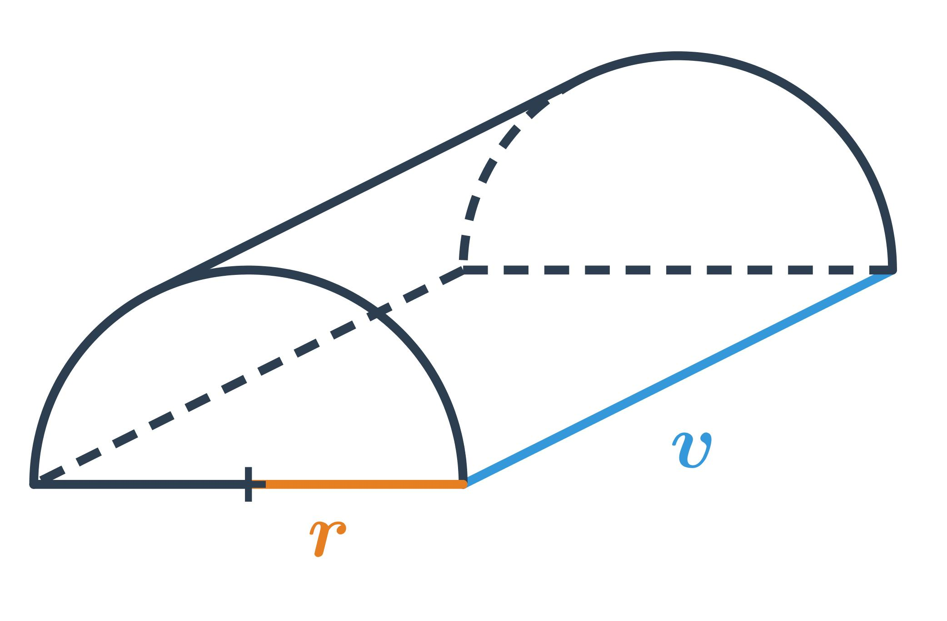

Geometric Structure
# Source: AI Source: Provided by: [Data Path: Persons Table -> ID Column: 1, Name_En Column: Motasem Essam] -> From: [ChatGPT] on [7/25/2026]
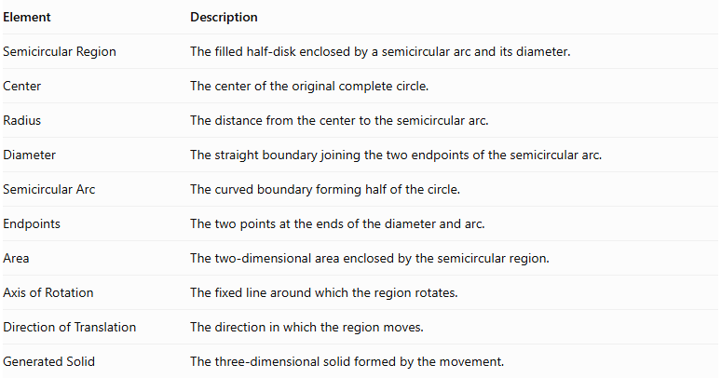
Element | Description
Semicircular Region | The filled half-disk enclosed by a semicircular arc and its diameter.
Center | The center of the original complete circle.
Radius | The distance from the center to the semicircular arc.
Diameter | The straight boundary joining the two endpoints of the semicircular arc.
Semicircular Arc | The curved boundary forming half of the circle.
Endpoints | The two points at the ends of the diameter and arc.
Area | The two-dimensional area enclosed by the semicircular region.
Axis of Rotation | The fixed line around which the region rotates.
Direction of Translation | The direction in which the region moves.
Generated Solid | The three-dimensional solid formed by the movement.

Types of Semicircular-Region Generators According to Movement

Rotational Semicircular-Region Generator
# Source: AI Source: Provided by: [Data Path: Persons Table -> ID Column: 1, Name_En Column: Motasem Essam] -> From: [ChatGPT] on [7/25/2026]
A semicircular region rotates around a fixed axis to generate a solid of revolution.
A. Rotation Around Its Diameter
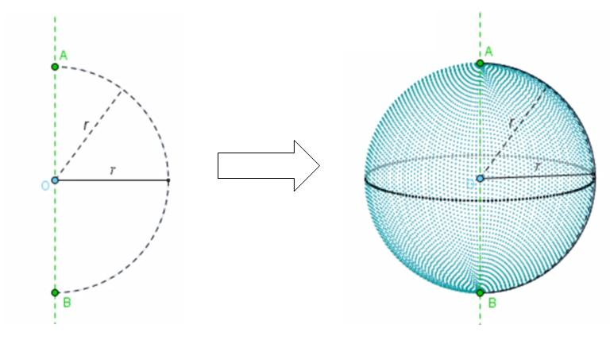
- Generates a Solid Sphere.
- The diameter acts as the axis of rotation.
- The radius of the semicircular region becomes the radius of the sphere.
- Every point in the semicircular region sweeps out a circular path around the diameter.
- The semicircular region fills the entire sphere during one complete rotation.
B. Rotation Around an External Coplanar Axis
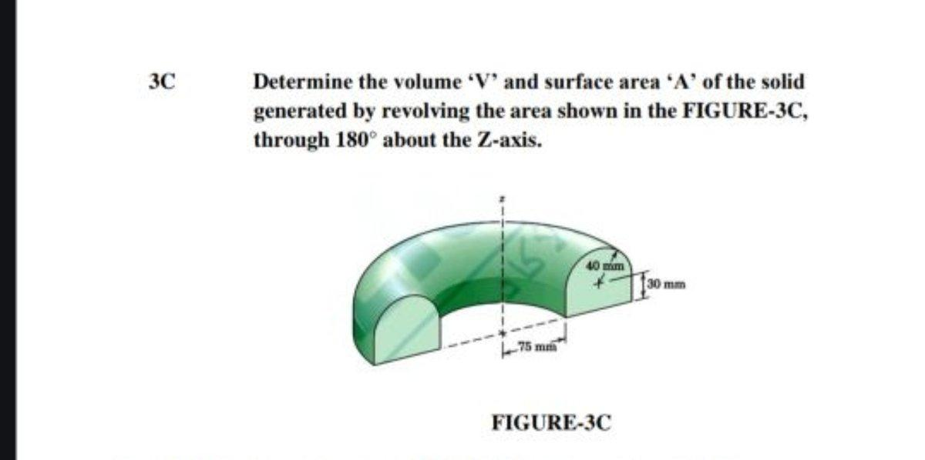
- Generates a solid of revolution with a toroidal-type geometry.
- The resulting form depends on the distance between the external axis and the semicircular region.
- Unlike a complete circular region, the semicircular region does not necessarily generate a complete toroidal solid.
C. Rotation Around an Axis Perpendicular to Its Plane and Passing Through Its Center
- The semicircular region remains geometrically unchanged during rotation.
- It generates the same semicircular region rather than a three-dimensional solid.

Mathematical Representation
# Source: AI Source: Provided by: [Data Path: Persons Table -> ID Column: 1, Name_En Column: Motasem Essam] -> From: [ChatGPT] on [7/25/2026]
Let a semicircular region have radius $r$.

Fundamental Measurements
# Source: AI Source: Provided by: [Data Path: Persons Table -> ID Column: 1, Name_En Column: Motasem Essam] -> From: [ChatGPT] on [7/25/2026]
Diameter:
$$d=2r$$
Area:
$$A=\frac{1}{2}πr^{2}$$
Curved arc length:
$$L=πr$$
Perimeter of the semicircular region:
$$P=πr+2r$$
Equation of the semicircular boundary:
For the upper semicircle centered at the origin:
$$x^{2}+y^{2}=r^{2}, y≥0$$
Or:
$$y=\sqrt{r^{2}-x^{2}}$$

Rotation Around the Diameter — Solid Sphere
# Source: AI Source: Provided by: [Data Path: Persons Table -> ID Column: 1, Name_En Column: Motasem Essam] -> From: [ChatGPT] on [7/25/2026]
Rotating the filled semicircular region around its diameter generates a solid sphere.
The sphere radius equals the semicircle radius:
$$R=r$$
Volume:
$$V=\frac{4}{3}πr^{3}$$
Surface area:
$$A_{s}=4πr^{2}$$
Equation of the resulting sphere:
$$x^{2}+y^{2}+z^{2}=r^{2}$$
The complete sphere is generated because every semicircular cross-section perpendicular to the diameter sweeps out a circular disk.

Perpendicular Translation — Half-Cylinder
# Source: AI Source: Provided by: [Data Path: Persons Table -> ID Column: 1, Name_En Column: Motasem Essam] -> From: [ChatGPT] on [7/25/2026]
When a semicircular region is translated perpendicularly to its plane through a distance $h$, it generates a Half-Cylinder (Semicircular Prism).
Volume:
$$V=\frac{1}{2}πr^{2}h$$
Curved lateral surface area:
$$A_{c}=πrh$$
Rectangular lateral face area:
$$A_{f}=2rh$$
Area of both semicircular ends:
$$A_{e}=πr^{2}$$
Total surface area:
$$A_{t}=πrh+2rh+πr^{2}$$

Oblique Translation — Oblique Semicircular Prism
# Source: AI Source: Provided by: [Data Path: Persons Table -> ID Column: 1, Name_En Column: Motasem Essam] -> From: [ChatGPT] on [7/25/2026]
When a semicircular region is translated obliquely to its plane, it generates an Oblique Semicircular Prism.
Its volume is:
$$V=\frac{1}{2}πr^{2}h$$
Where $h$ is the perpendicular distance between the two parallel semicircular bases.
The slanted translation distance is not necessarily equal to this perpendicular height.

Mathematical Properties
# Source: AI Source: Provided by: [Data Path: Persons Table -> ID Column: 1, Name_En Column: Motasem Essam] -> From: [ChatGPT] on [7/25/2026]
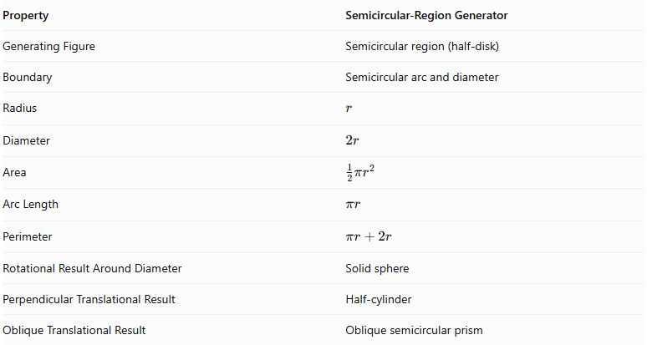
Property | Semicircular-Region Generator
Generating Figure | Semicircular region (half-disk)
Boundary | Semicircular arc and diameter
Radius | $$r$$
Diameter | $$2r$$
Area | $$\frac{1}{2}πr^{2}$$
Arc Length | $$πr$$
Perimeter | $$πr+2r$$
Rotational Result Around Diameter | Solid sphere
Perpendicular Translational Result | Half-cylinder
Oblique Translational Result | Oblique semicircular prism

Generated Surfaces and Solids

Solid Sphere
# Source: AI Source: Provided by: [Data Path: Persons Table -> ID Column: 1, Name_En Column: Motasem Essam] -> From: [ChatGPT] on [7/25/2026]
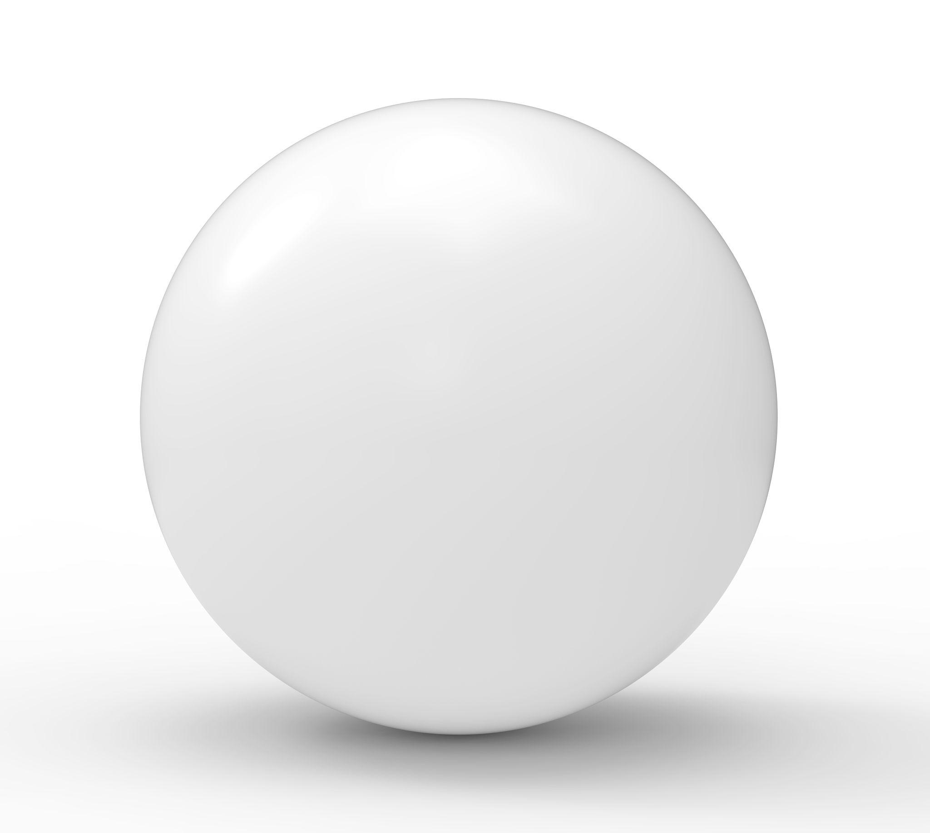
Generated by rotating a semicircular region around its diameter.

Half-Cylinder (Semicircular Prism)
# Source: AI Source: Provided by: [Data Path: Persons Table -> ID Column: 1, Name_En Column: Motasem Essam] -> From: [ChatGPT] on [7/25/2026]
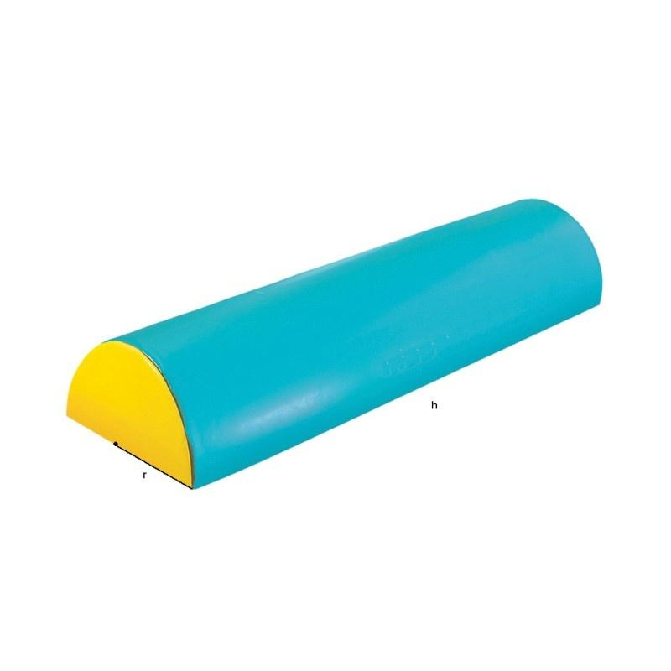
Generated by translating a semicircular region perpendicularly to its plane.

Oblique Semicircular Prism
# Source: AI Source: Provided by: [Data Path: Persons Table -> ID Column: 1, Name_En Column: Motasem Essam] -> From: [ChatGPT] on [7/25/2026]
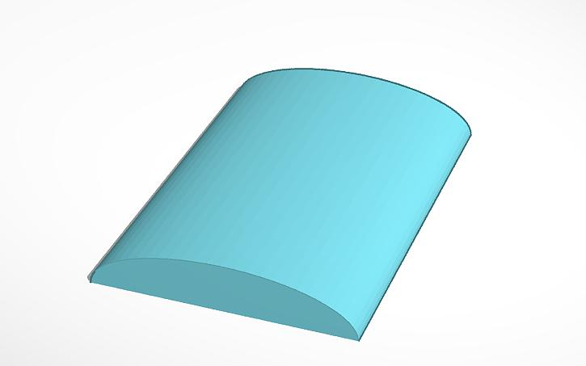
Generated by translating a semicircular region in an oblique direction relative to its plane.

Applications
# Source: AI Source: Provided by: [Data Path: Persons Table -> ID Column: 1, Name_En Column: Motasem Essam] -> From: [ChatGPT] on [7/25/2026]
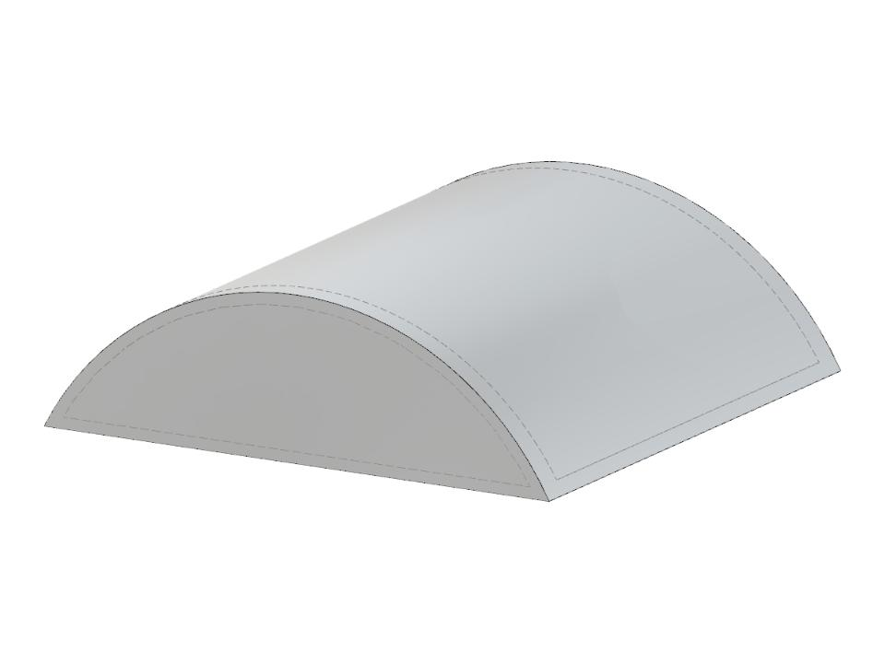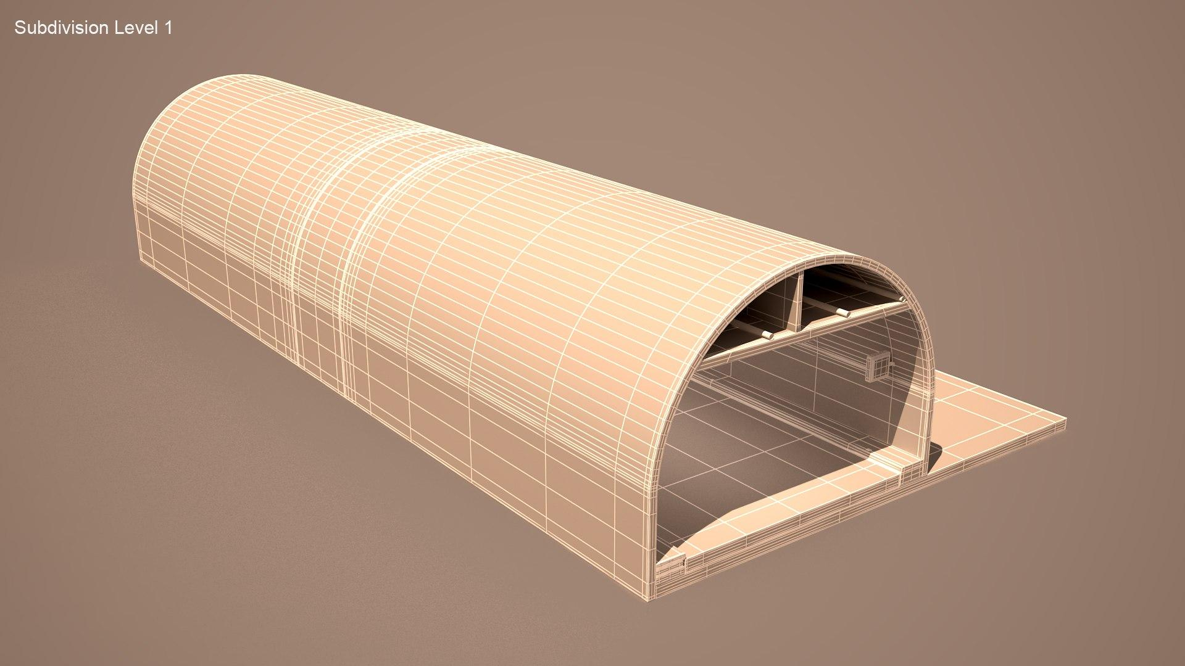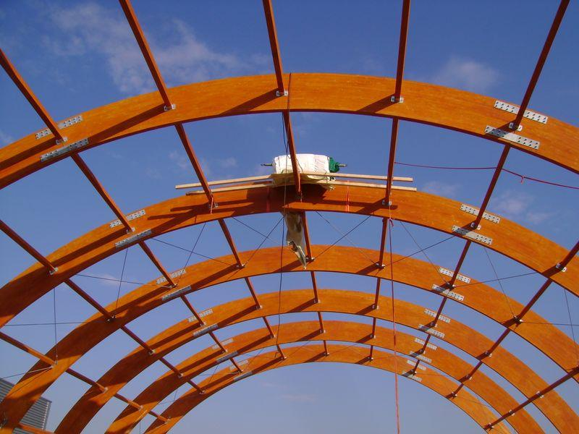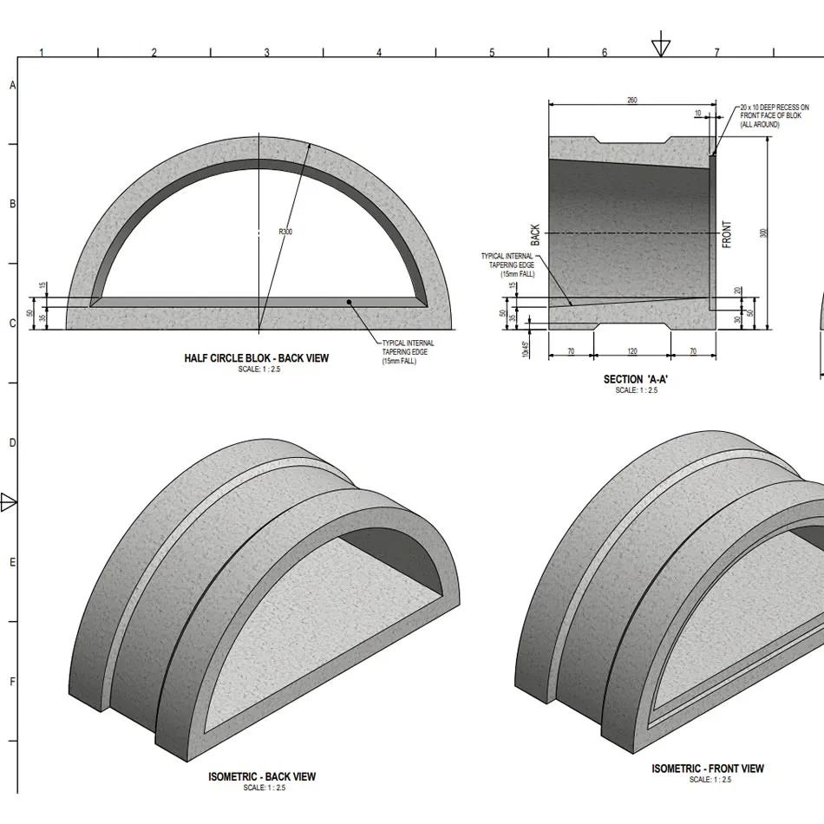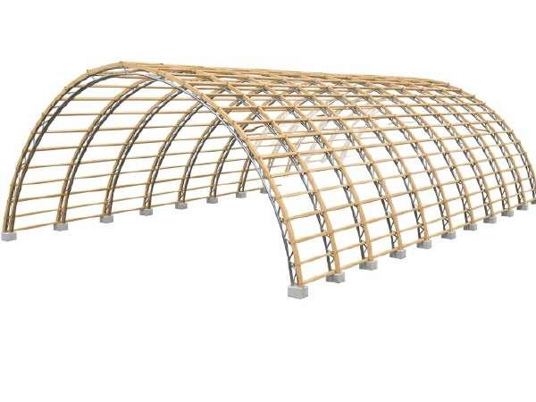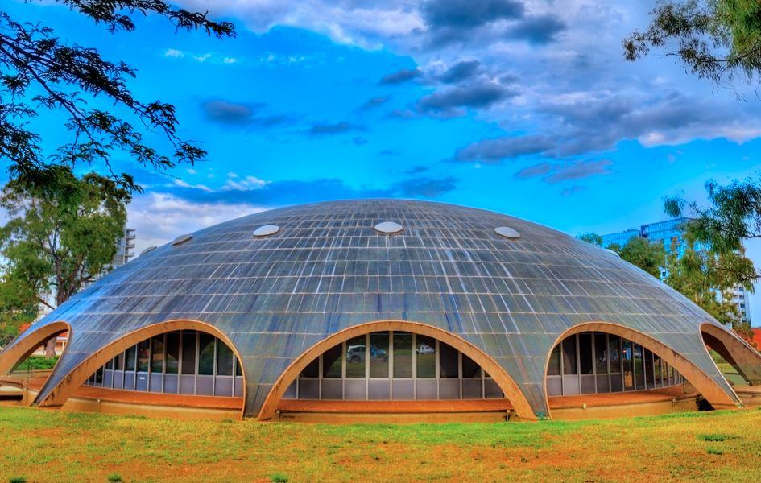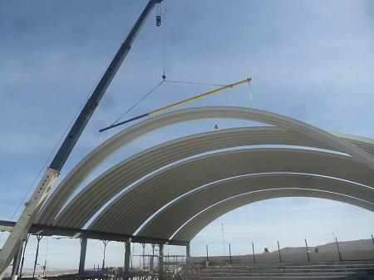
- Spherical Structures: Spherical tanks and dome-shaped structures.
- Architectural Domes: Semicircular profiles are used in dome and vault design.
- Half-Cylindrical Structures: Tunnels, shelters, and curved roofs.
- Engineering Components: Semicircular channels and structural sections.

Comparison with Other Plane-Region Generators
# Source: AI Source: Provided by: [Data Path: Persons Table -> ID Column: 1, Name_En Column: Motasem Essam] -> From: [ChatGPT] on [7/25/2026]
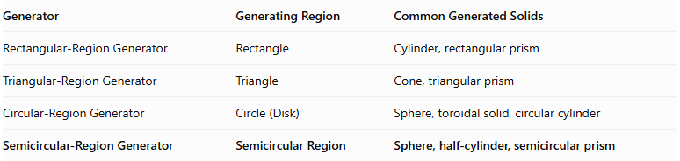
Generator | Generating Region | Common Generated Solids
Rectangular-Region Generator | Rectangle | Cylinder, rectangular prism
Triangular-Region Generator | Triangle | Cone, triangular prism
Circular-Region Generator | Circle (Disk) | Sphere, toroidal solid, circular cylinder
Semicircular-Region Generator | Semicircular Region | Sphere, half-cylinder, semicircular prism

Main Classification
# Source: AI Source: Provided by: [Data Path: Persons Table -> ID Column: 1, Name_En Column: Motasem Essam] -> From: [ChatGPT] on [7/25/2026]
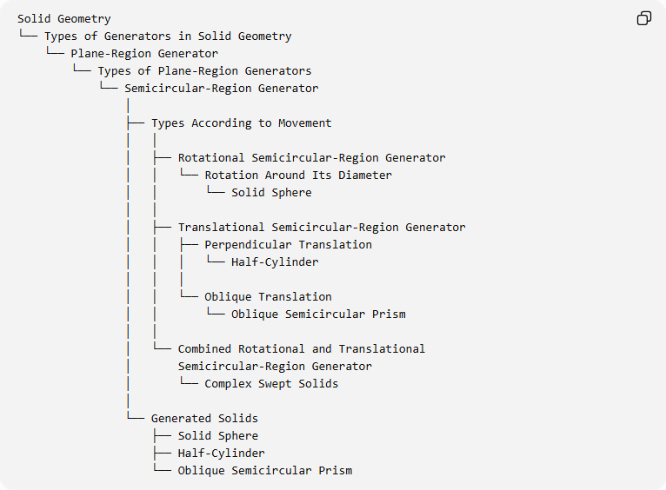
Solid Geometry
└── Types of Generators in Solid Geometry
└── Plane-Region Generator
└── Types of Plane-Region Generators
└── Semicircular-Region Generator
│
├── Types According to Movement
│ │
│ ├── Rotational Semicircular-Region Generator
│ │ └── Rotation Around Its Diameter
│ │ └── Solid Sphere
│ │
│ ├── Translational Semicircular-Region Generator
│ │ ├── Perpendicular Translation
│ │ │ └── Half-Cylinder
│ │ │
│ │ └── Oblique Translation
│ │ └── Oblique Semicircular Prism
│ │
│ └── Combined Rotational and Translational
│ Semicircular-Region Generator
│ └── Complex Swept Solids
│
└── Generated Solids
├── Solid Sphere
├── Half-Cylinder
└── Oblique Semicircular Prism

Key Points
# Source: AI Source: Provided by: [Data Path: Persons Table -> ID Column: 1, Name_En Column: Motasem Essam] -> From: [ChatGPT] on [7/25/2026]
- A semicircular-region generator uses a filled half-disk as its generating figure.
- Rotating a semicircular region around its diameter generates a solid sphere.
- Translating it perpendicularly to its plane generates a half-cylinder.
- Oblique translation generates an oblique semicircular prism.
- The area of the semicircular region is half the area of a complete circle with the same radius.
- The generating region and its boundary must be distinguished: rotating the semicircular region produces a sphere, while rotating only its arc produces a spherical surface.

Conclusion
# Source: AI Source: Provided by: [Data Path: Persons Table -> ID Column: 1, Name_En Column: Motasem Essam] -> From: [ChatGPT] on [7/25/2026]
The Semicircular-Region Generator is a plane-region generator that produces spherical and prismatic solids through different types of movement. Its most important application is the generation of a solid sphere by rotating a semicircular region around its diameter.

